**Case Study 9**

**Profile of M/s SDSS**

|  |  |
| --- | --- |
| **Name of Enterprise** | M/s SDSS |
| **Partners** | Mr. D  Mrs. K |
| **Constitution** | Partnership Firm |
| **Factory Address** | Hyderabad |
| **Established** | 2016 (The units is yet start its commercial operations) |
| **Line of activity** | Manufacturing of BOPP (Biaxially Oriented Polypropylene Films), LD (Low Density Polyethylene), Laminated Poly films for packaging FMCG products and other goods |
| **Udyog Aadhaar/SSI Registration No.** |  |
| **GST** |  |

1. **Line of Activity**

Entrepreneur engaged in manufacturing of Manufacturing of BOPP (Biaxially Oriented Polypropylene Films), LD (Low Density Polyethylene), Laminated Poly films for packaging FMCG products and other goods. The finished products are used in Food-packaging such as chips packets, Shampoo sachets etc.,

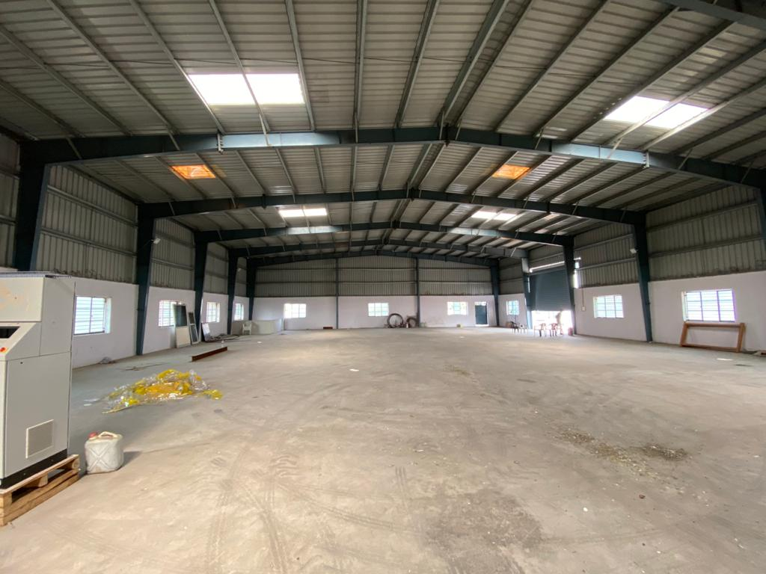

1. **Managerial Competencies**:

Entrepreneur Mr D is an MBA postgraduate aged 32 years. He worked as investment banker in an MNC for 5 years. Later with support of his family he entered into trading of Non-Woven bags and gained knowledge and experience of 4 years in trading and manufacturing of plastic packaging industry. Further, with prior experience and his hard-earned money, he established manufacturing unit of poly films by loan facility from APSFC in the year 2016. The constitution of establishment is partnership consisting himself and his mother Mrs. D Udaya. He has two siblings one elder brother and one younger sister. His brother is also a businessman in Real Estate Sector. His sister is married and lives in USA. His family is ready to support him to make his business successful.

1. **Machinery:**

Civil works are completed. Constructed shed by using quality Essar brand material over an area of 2400 yards. Quality check lab also constructed. All the machinery equipment (printing, laminating and cutting) has been installed in the unit and entrepreneur also engaged 5 employees. The machinery is from a reputed brand Rotoflex Industries.

1. **Brief History:**

Commercial production not started yet. Enterprise was sanctioned a term loan of ₹22.00 million by APSFC in the year 2016. By the end of August 2019, the total loan disbursed was ₹15.5 million only. The moratorium period has ended in the month of May 2019. From September 2019, SFC is not disbursing pending amount of ₹6.5 million due to some internal issues in their organization. By the end of October 2019, total construction was completed. There were extra costs incurred by the entrepreneur due to delay in release of funds. This has resulted shortage in margin money to be contributed by the borrower for disbursal towards balance machineries. Due to delay in release of funds by primary lender, entrepreneur was not able to start commercial production as the remaining as supply of machineries of Laminating and Cutting & Slitting was held up by the supplier.

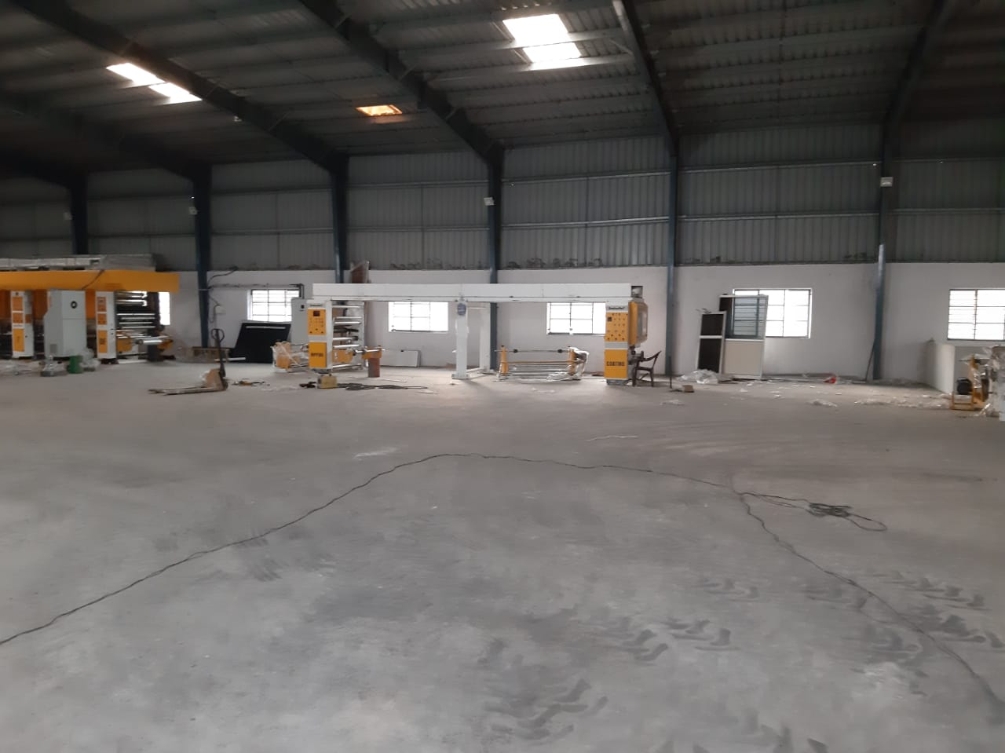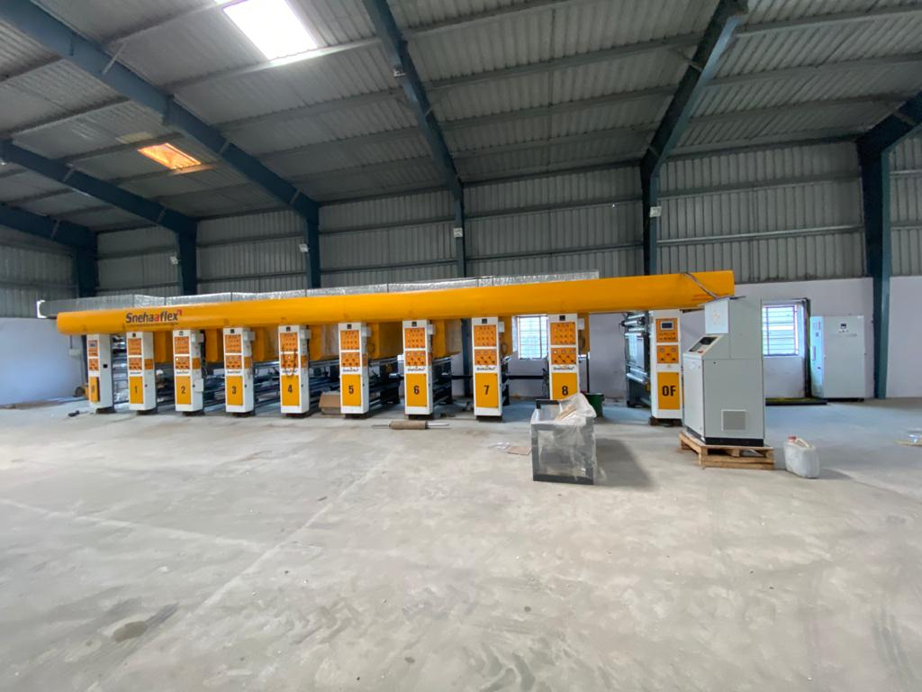

**M/S SDSS**

1. **Manufacturing Process:**

There are three machineries which are Printing, Laminating and Cutting. First, the raw material which is BOPP or LD film rolls are placed on printing machinery. Once the label is printed on the film, then it moves to second step called laminating. The printed roll will be placed on laminating machine so that the film gets thickness and improvisation. Then the final step is cutting the rolls in required dimensions as mentioned by the buyers. These sheets are then kept for quality check and then for dispatch.

1. **Marketing:**

* Enterprise has good potential in domestic market in Telangana State
* There is good demand for the product from food processing, fertilizers and FMCG sector.
* He is self-marketing his product and getting orders from known customers.
* He also making arrangements to register on GEM and other marketing platforms.

1. **TIHCL intervention:**

Enterprise approached TIHCL for providing margin money for release of pending machinery because of inability of APSFC to release the sanctioned amount fully owing to issues relating to division of Telangana and Andhra Pradesh States.

TIHCL has diagnosed the enterprise and identified following reasons of sickness

* Delay in disbursement of sanctioned amount
* Incomplete financial closure by the primary lender
* Additional amount brought in by the firm for completion of civil works due to partial release of funds which caused financial stress on firm.
* Installation of partial machinery restricting the firm to enter commercial production.

As per TIHCL resolution package, SFC (Primary lender) had released pending term loan of ₹2.7 million and extended moratorium of 1 year. TIHCL provided margin loan of ₹2.4 million in addition to SFC loan for release of machinery which is a total of ₹5.1 million. Further, the pending machinery of laminating and cutting was installed in the unit and ready to start commercial production.

|  |  |  |
| --- | --- | --- |
| **Key indicators** | **Pre-Revival** | **Post TIHCL intervention** |
| No of EMIs pending with primary lender | 0 | 0 |
| Capacity Utilization | 0 | 50% |
| Turnover | 0 | ₹25.00 million (Annualized) |
| Employment | 0 | 5 |

1. **Labor Status: (post TIHCL intervention)**

|  |  |  |
| --- | --- | --- |
| Gender | Skilled | Unskilled |
| Men | 1 | 4 |
| Women | 0 | 0 |
| Total | 1 | 4 |

**Livelihood:** Enterprise created employment to 5 workers at 50% of capacity and may require another 5 to 6 workers during full capacity**.**